Solution for questions 1 and 2. Both use the exact same methods just with their respective data. So only one will show the step by step but both will have the answer shown at the end along with the dashboard solution.

1. Step-by-step

1.

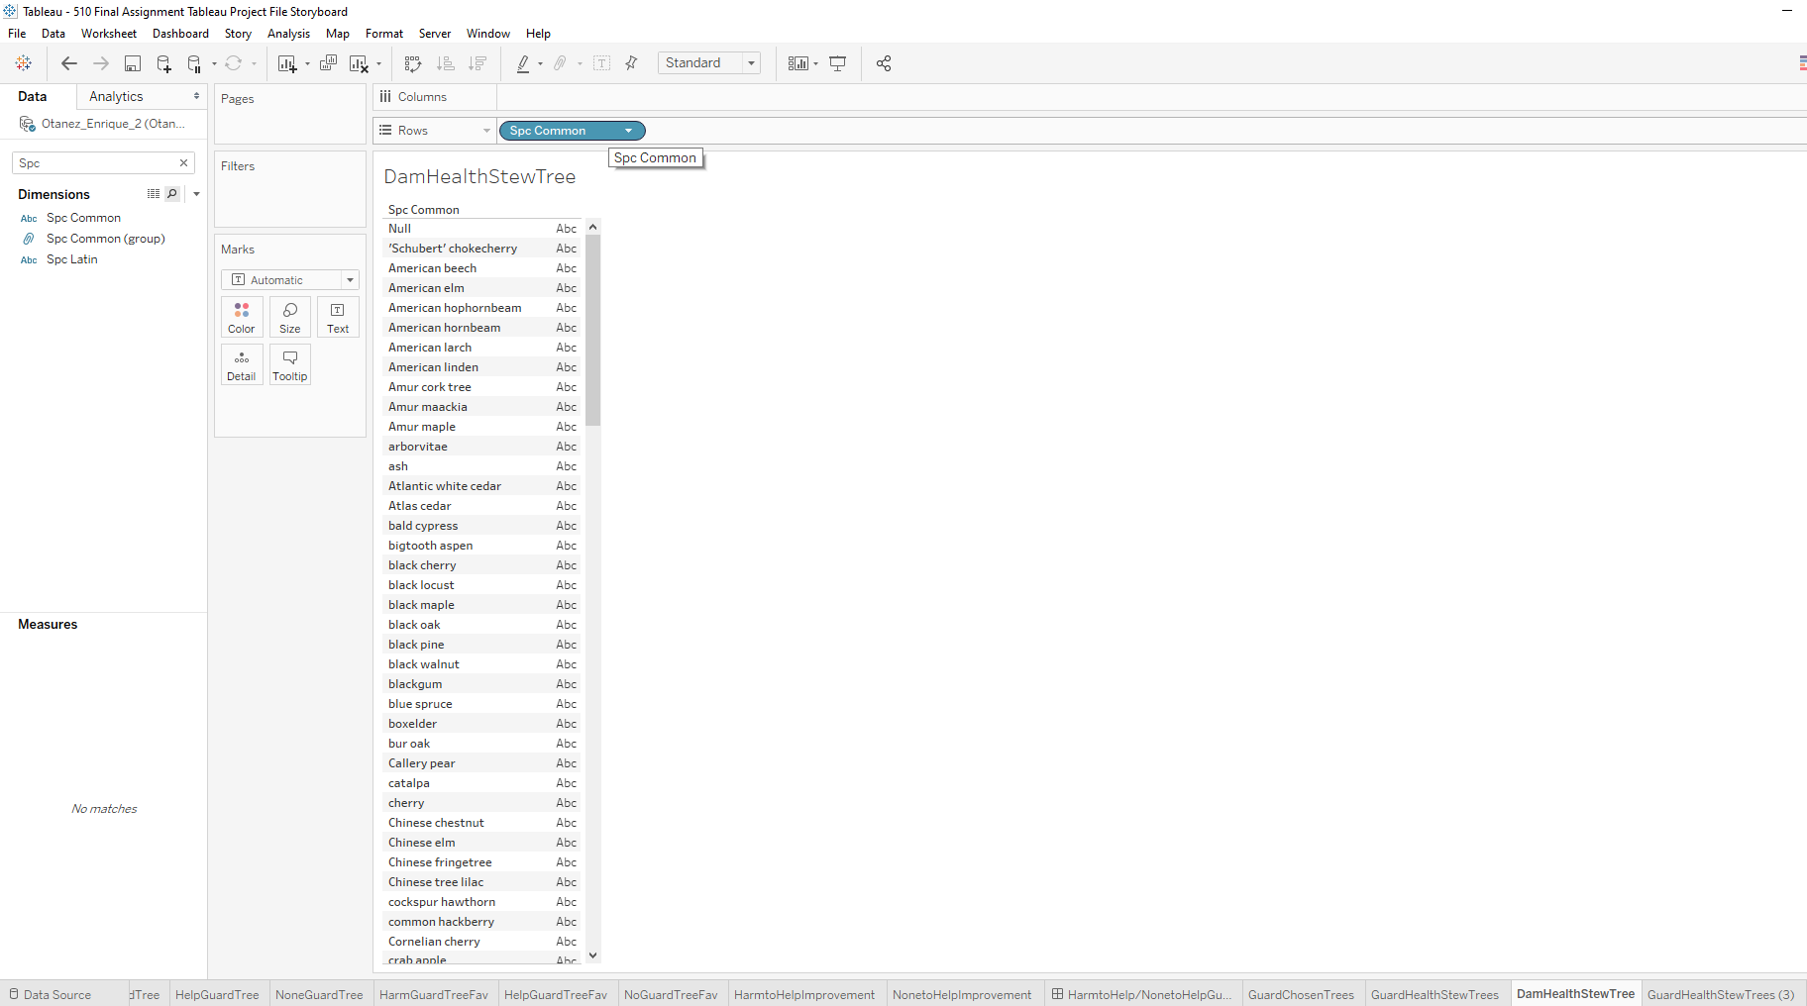

2.

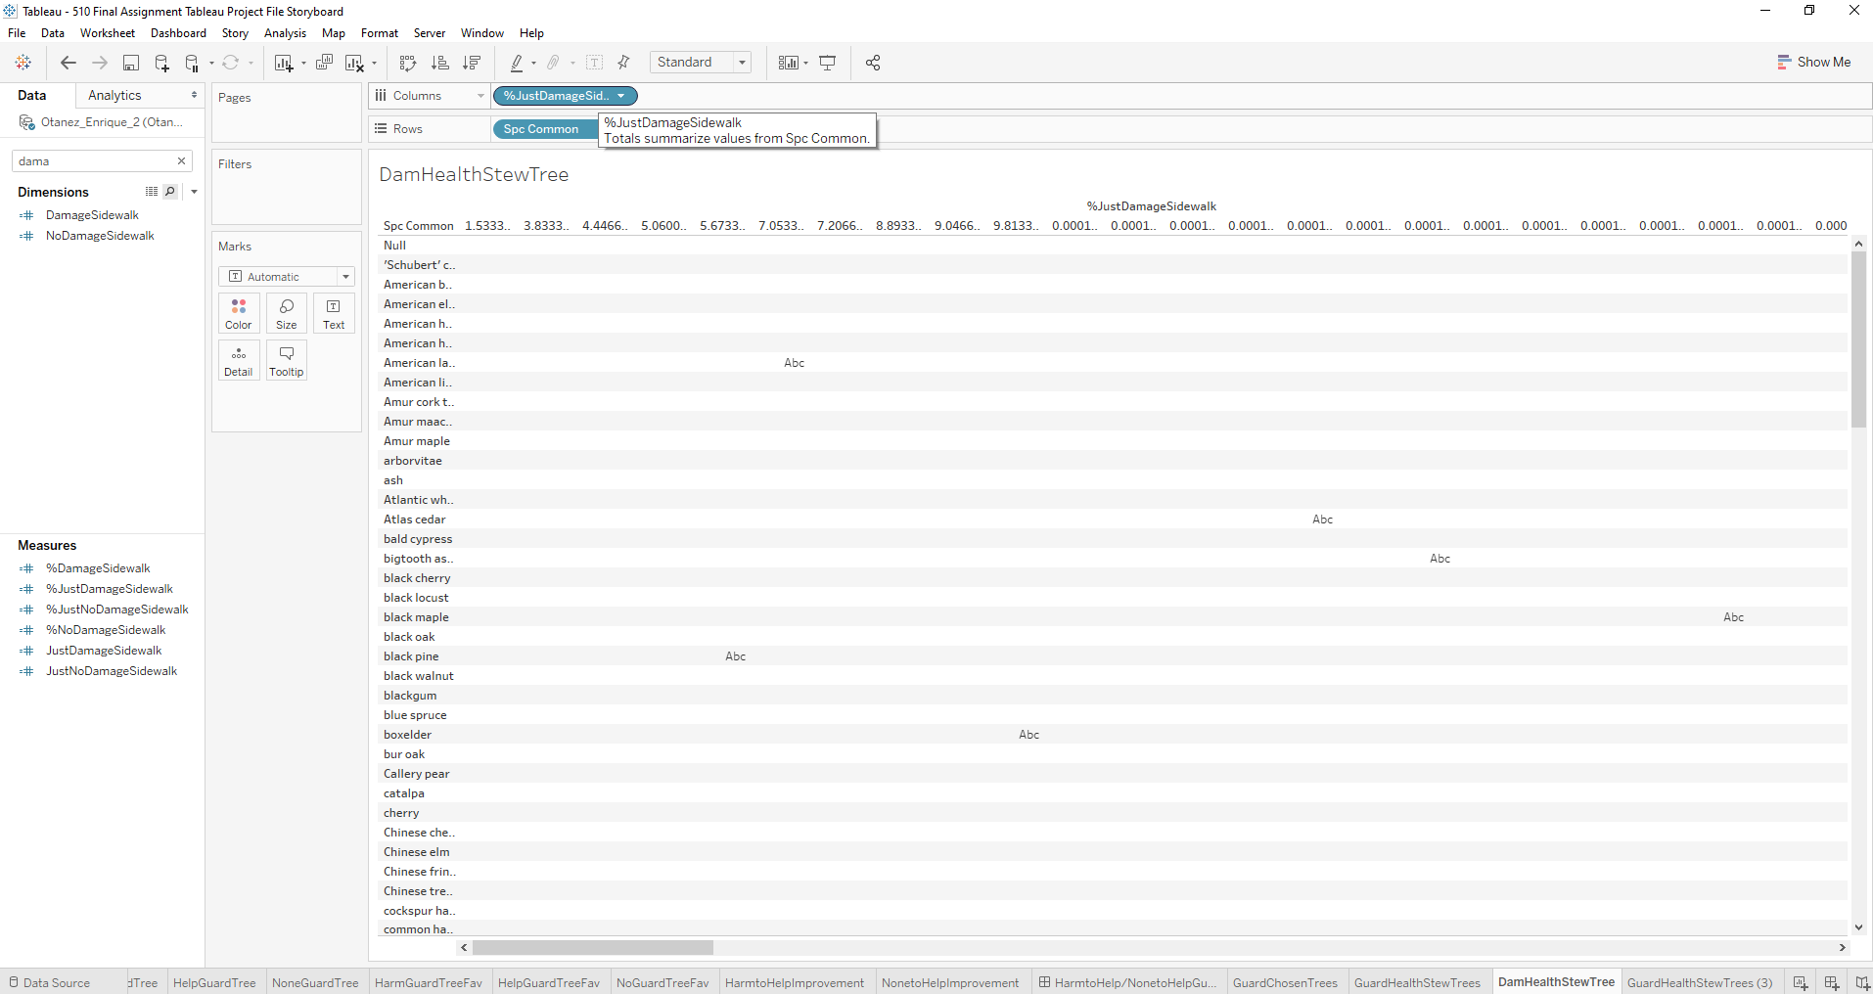

3.

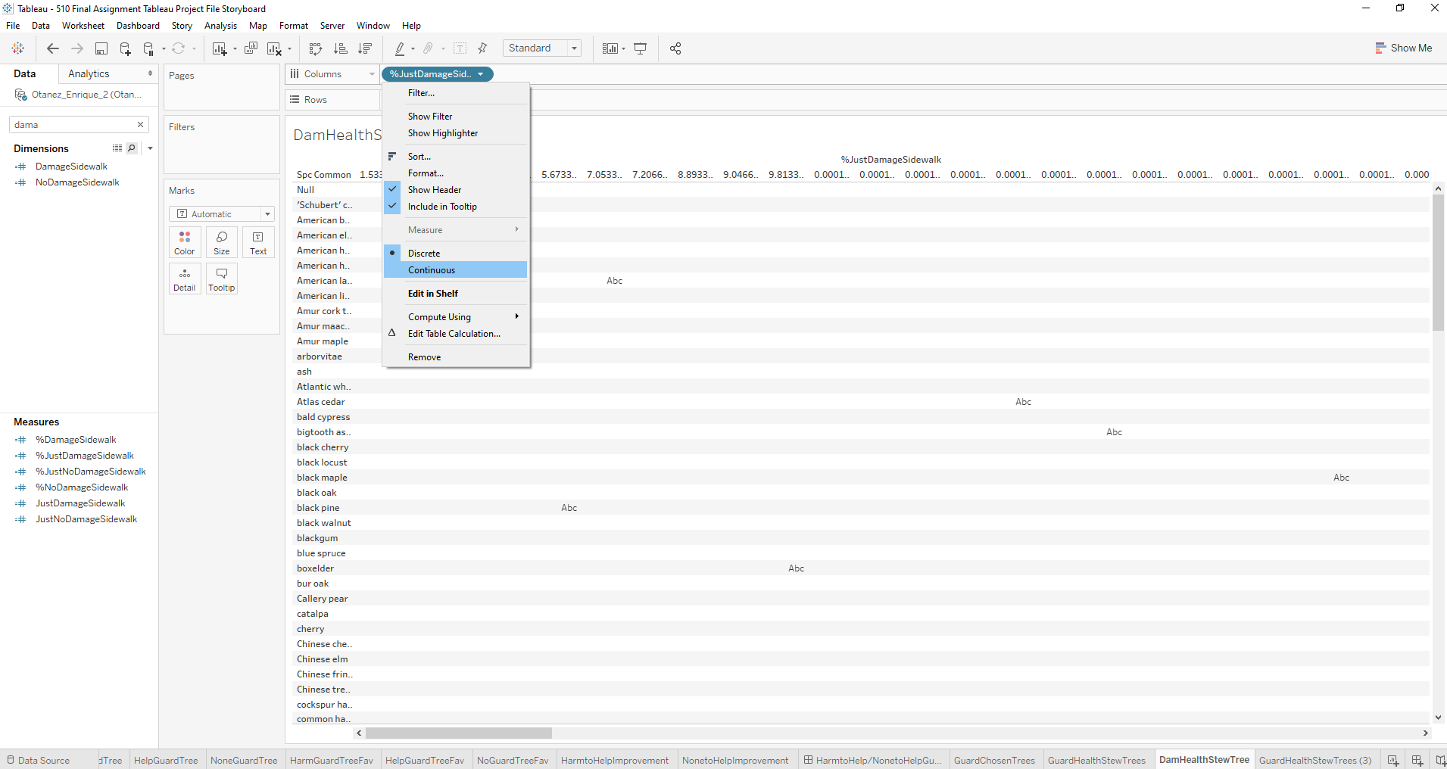

4.

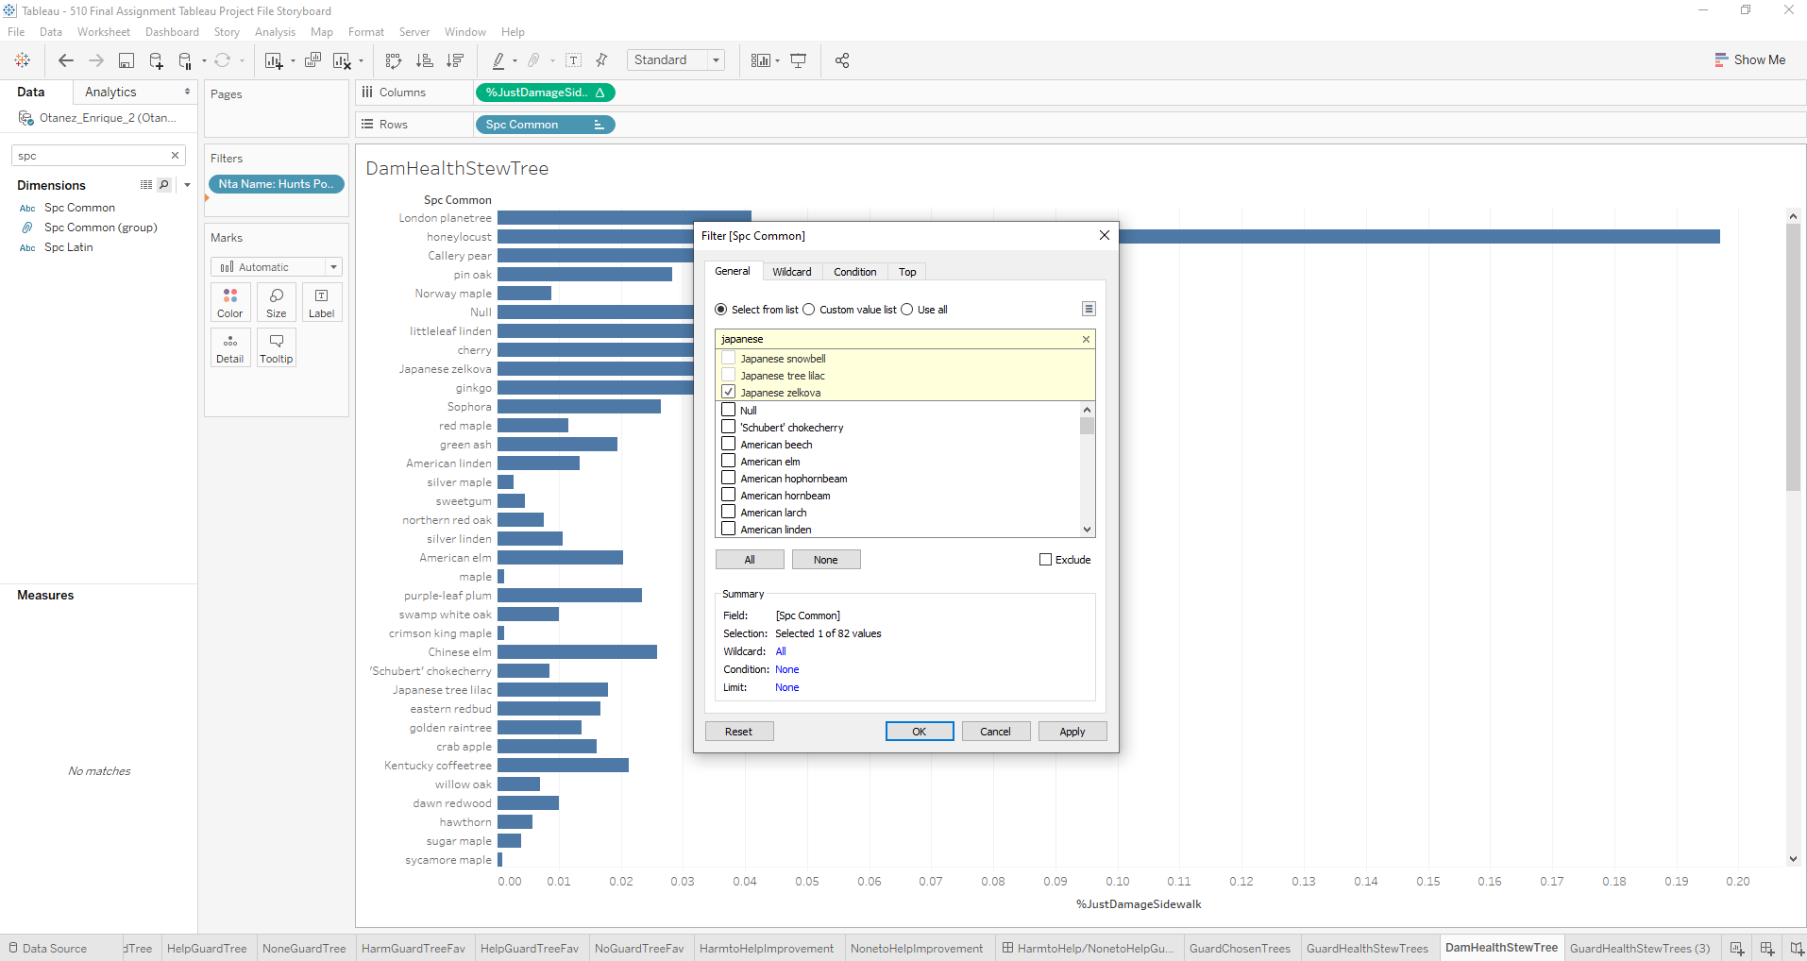

5.

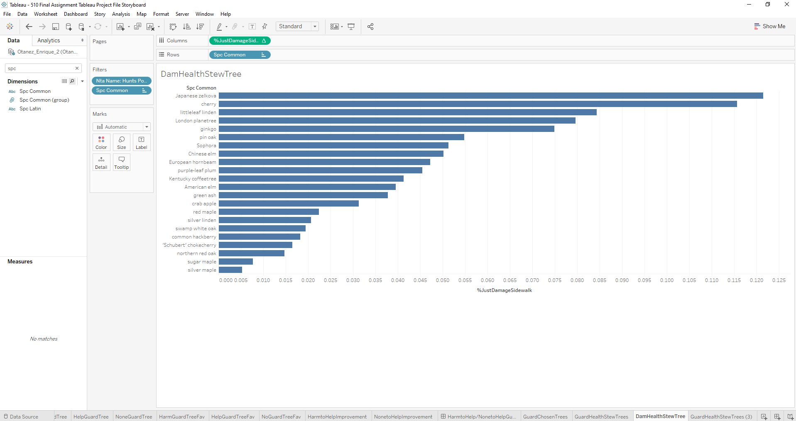

6.

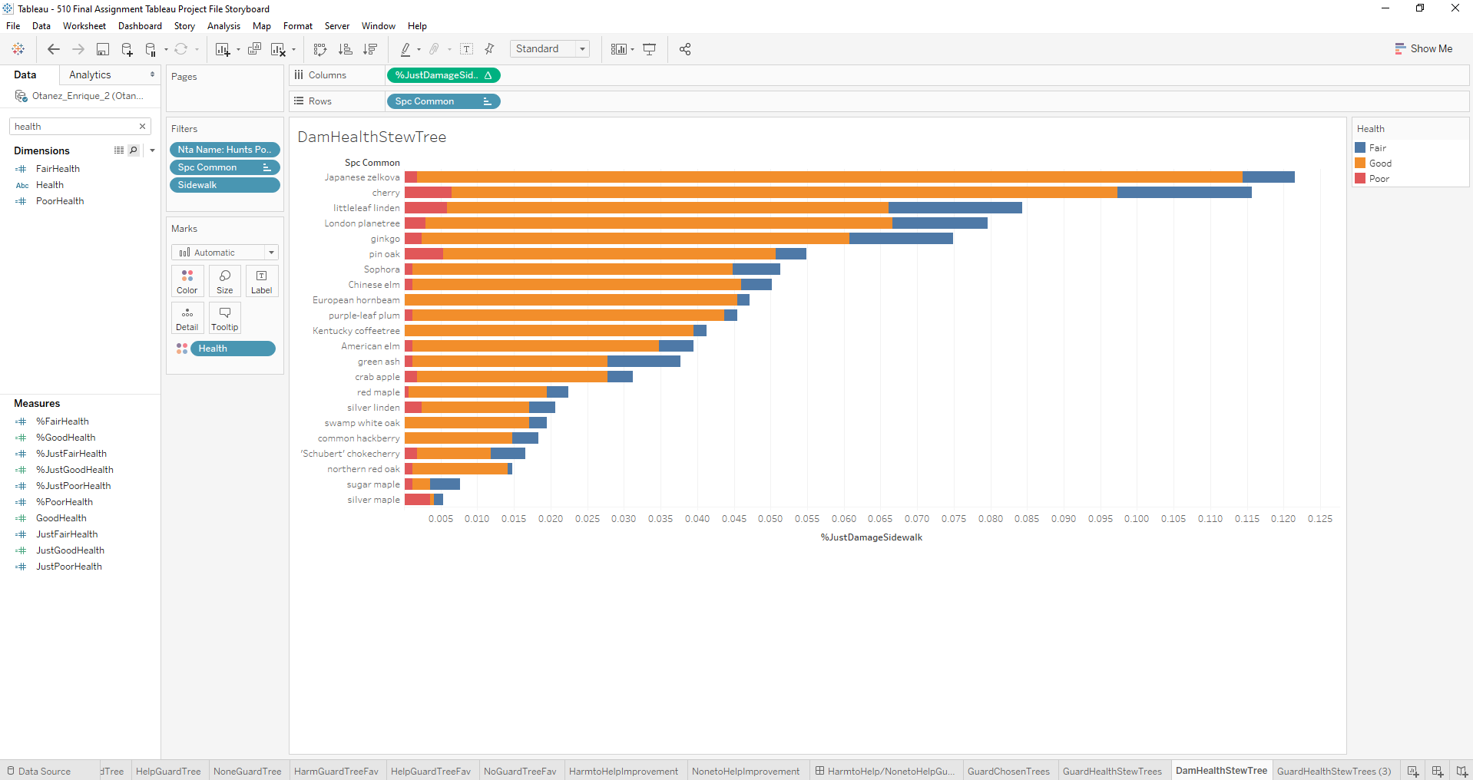

7.

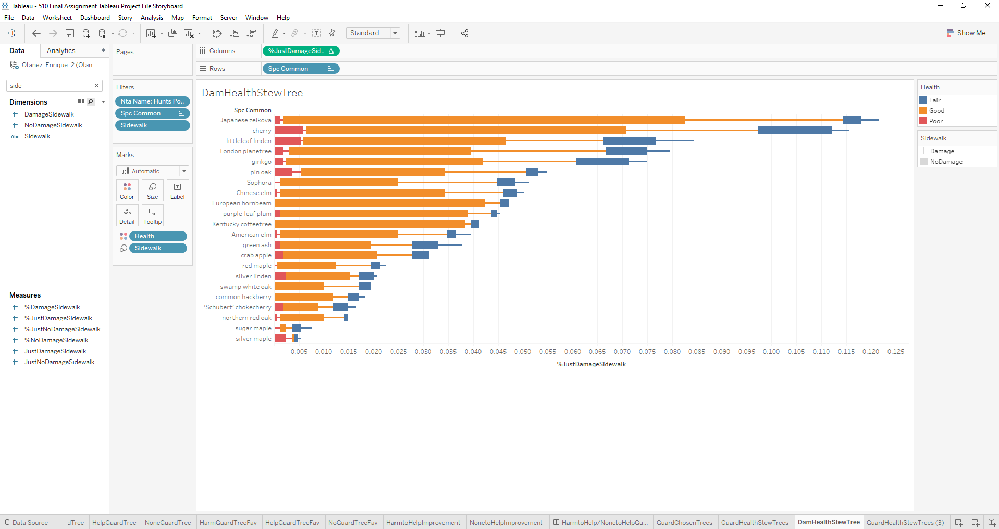

Picture 1 is where you want to bring over spc common name to the rows bar. It is important because this is the bases of your analysis. Simply click and drag spc common over to the rows bar and let it auto generate.

Picture 2 is where you want to bring over %JustDamageSidewalk over to the column bar. This is the same action that takes place in picture 1. The result will be a big datasheet looking result with different ABC all over the place.

Picture 3 is where you change %JustDamageSidewalk from discrete to continuous. To fix the result in picture 2, simply go to the #JustDamageSidewalk drop down arrow and click continuous to change the output of the two variables.

Picture 4 is where you drag nta_name to filter and filter by Hunt’s Point. Now to centralize on Hunt’s Point. Drag over nta_name just like spc common and %JustDamageSidewalk but instead drop it into the filter section of the analysis. Search and select Hunt’s point and press ok.

Picture 5 is where you then order the data to look cleaner rather than random. Order the data by clicking the three buttons directly under the serve tab in the ribbon up above. Those three will transpose and order from highest to lowest so the data does not look so random.

Picture 6 is where you insert health into the color marks box. Next is to insert health into the color of the mark box. As stated in the assignment, you can have this in any of the other mark boxes but health is needed to answer this question correctly.

Picture 7 is where you bring sidewalk over to size in the mark box. This is to show the other dimension at play here in the analysis. So, this time like health, you drag the pill from the left and drop it into whatever mark box you believe to be the most significant.

Solution in the solution section.

3. Step-by-step

1.

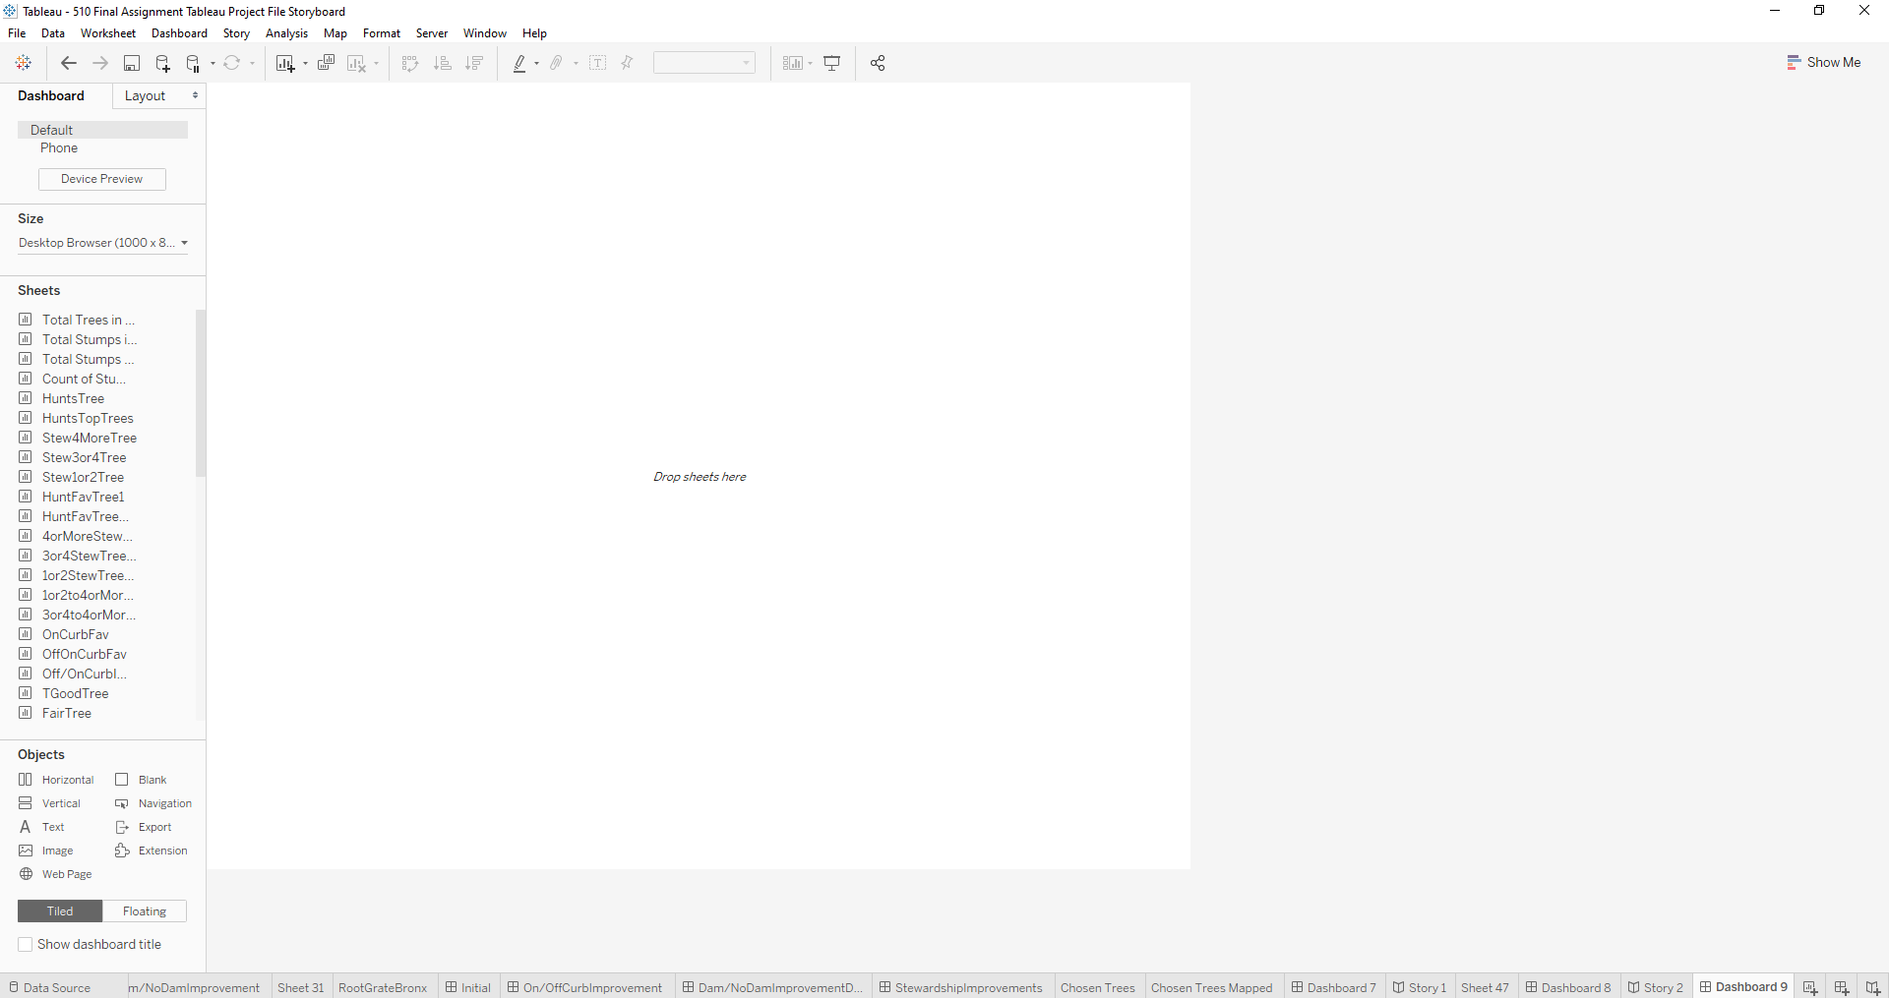

2.

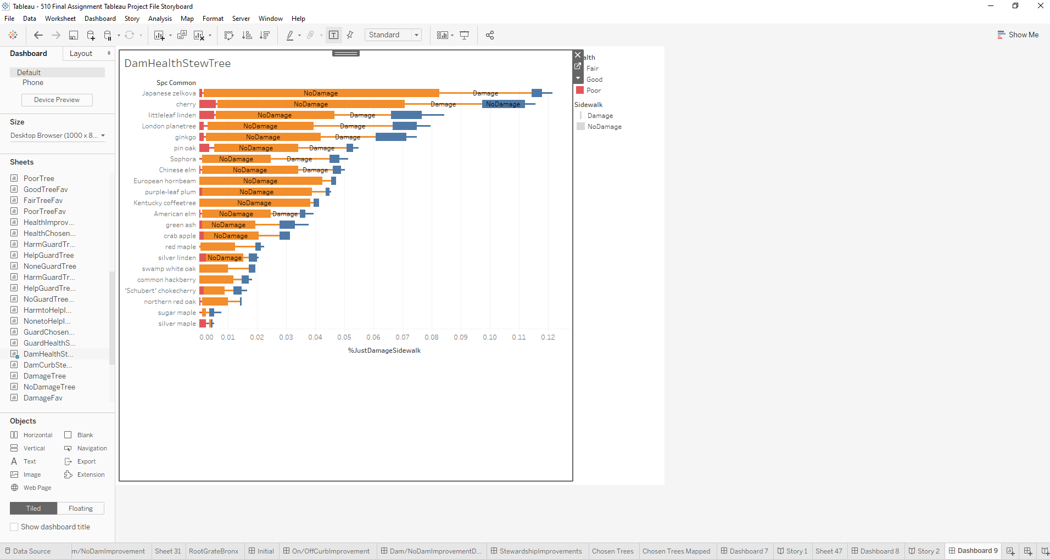

3.

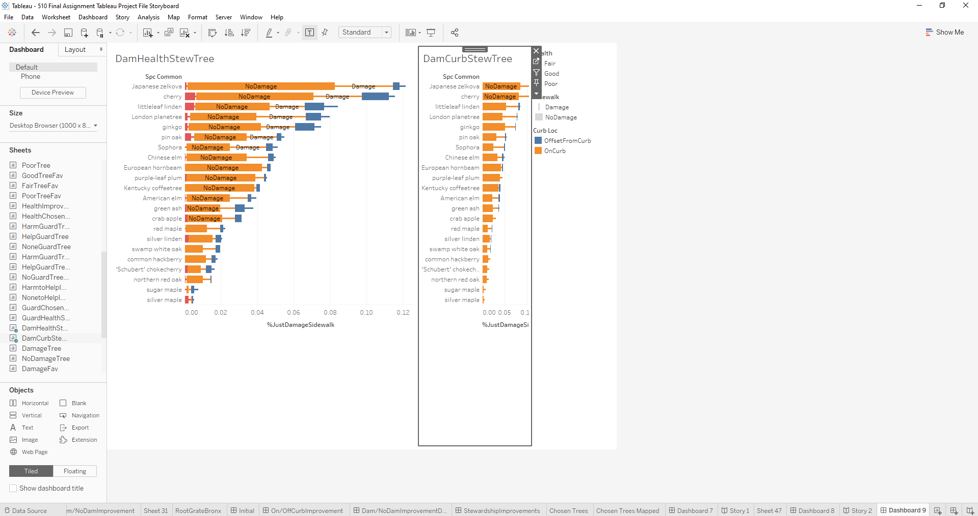

Picture 1 is when you open a new dashboard. Simple select the dashboard option like when you go to make a new sheet shown in the tutorial. The result is a blank canvas dashboard for you to bring over your visualizations.

Picture 2 is where you drag DamHealthStrewTree sheet into the dashboard pane. Drag over DamHealthStrewTree over from the left side into the pane. The result is picture 2 auto generated.

Picture 3 is where you bring over DamCurbStrewTree into the dashboard pane. Doing the same for picture 3 as picture 2, dragging DamCurbStrewTree over from the left into the pane, the results are little wonky.

Solution in solution section. To fix that move around and manipulate the data as best you can. The solution for this question shows a good example of it looking better.

Solution:

1.

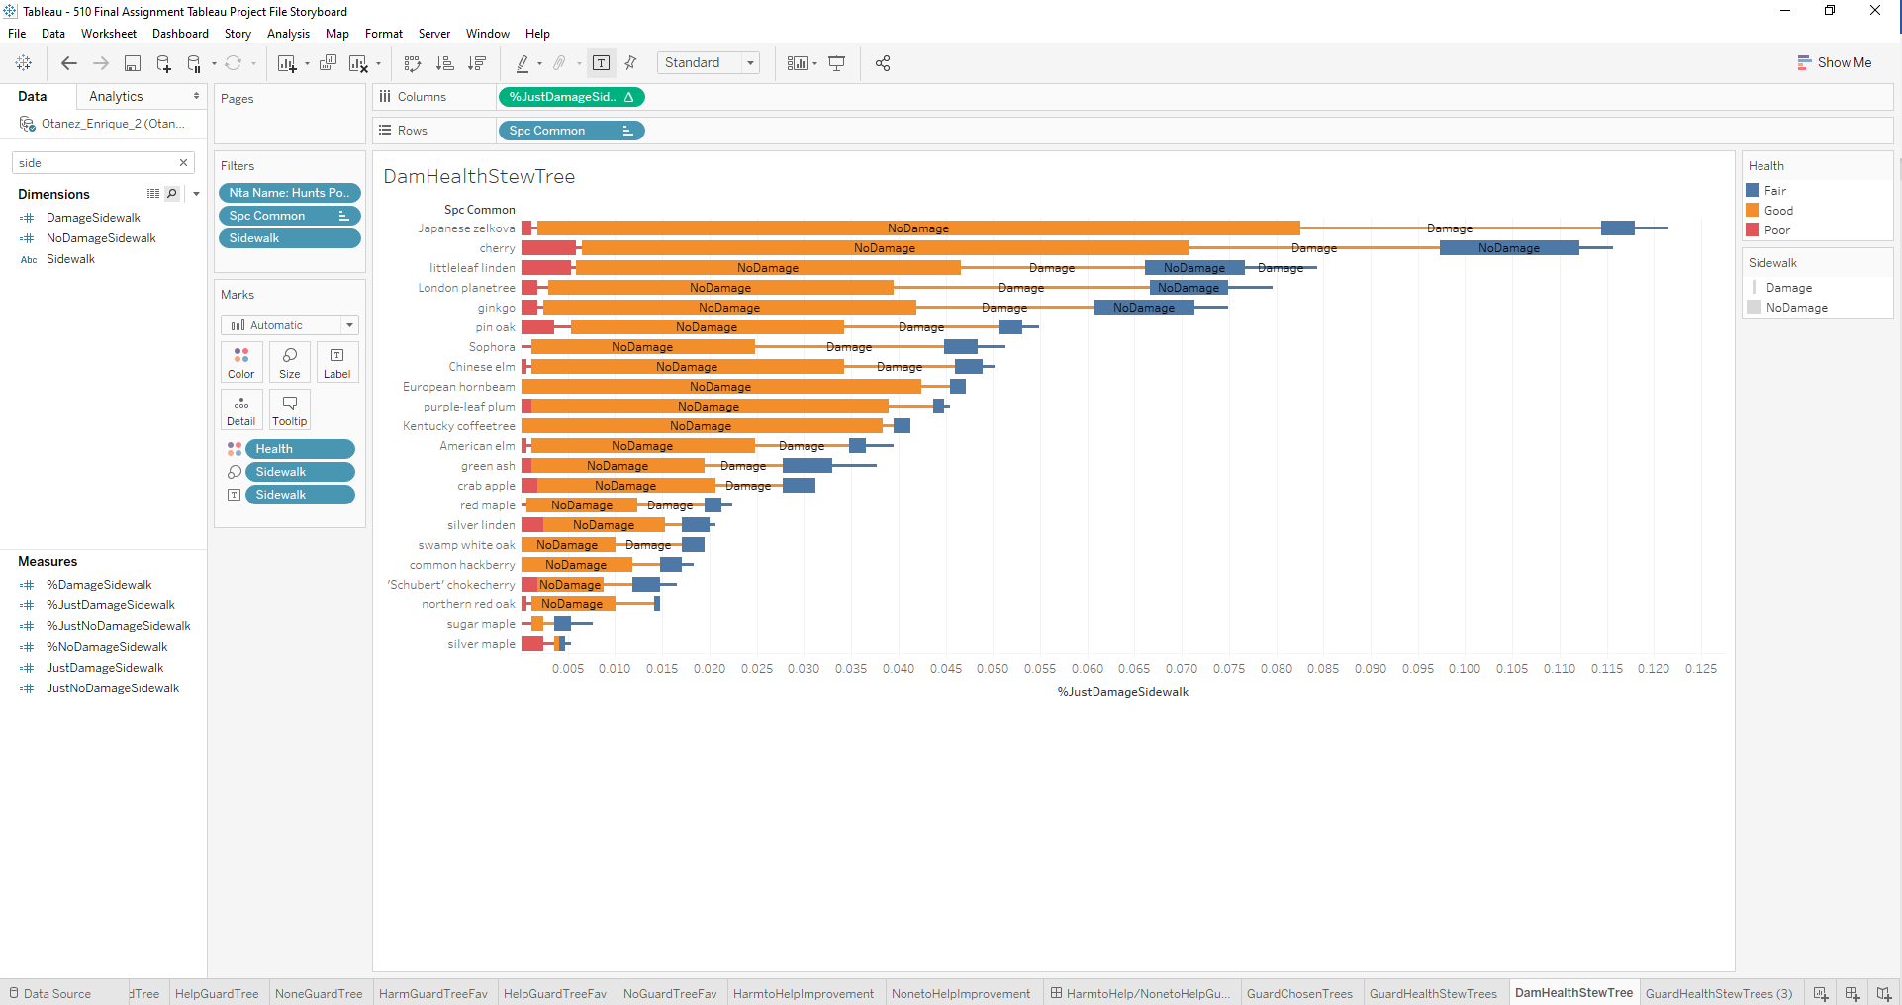

2.

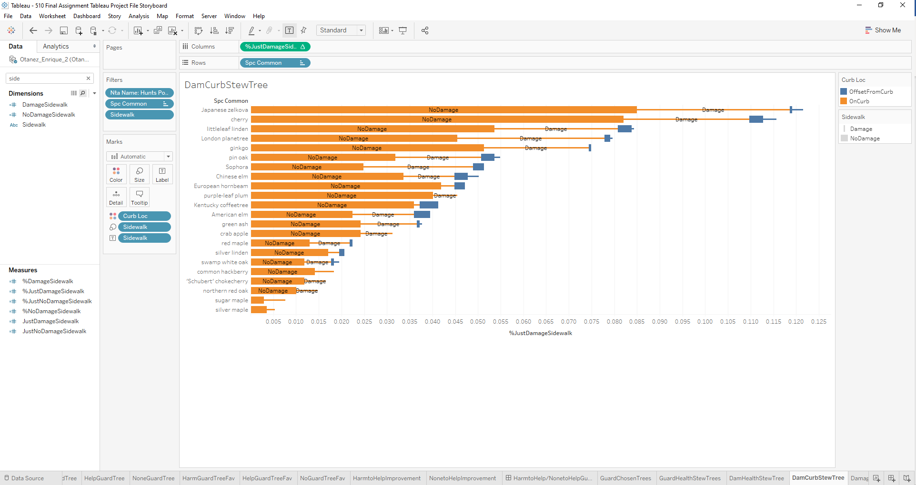

3.

